Data Analytics (DA)

Module-End -3

Module End Assignment:

“Analyzing E-Learning Platform Purchases using MySQL”

Assignment Task Overview

Problem Statement:
An online learning platform sells various digital courses to learners across different countries. Each learner can purchase multiple courses, and each course belongs to a specific category.

The management team wants to analyze purchase data to understand sales trends, learner behavior, and popular course categories.

-- Create Database
CREATE DATABASE IF NOT EXISTS elearning_db;
USE elearning_db;

-- Table 1: learners
create table learners (
learner_id int primary key auto_increment,
full_name varchar(100) not null,
country varchar(50) not null
);

-- Table 2: courses
create table courses (
course_id int primary key auto_increment,
course_name varchar(100) not null,
category varchar(50) not null,
unit_price decimal(10, 2) not null
);

-- Table 3: purchases
create table purchases (
purchase_id int primary key auto_increment,
learner_id int not null,
course_id int not null,
quantity int not null check (quantity > 0),
purchase_date date not null,
foreign key (learner_id) references learners(learner_id),
foreign key (course_id) references courses(course_id)
);

-- Insert Learners
insert into learners (full_name, country) values
('John Smith', 'USA'),
('Priya Sharma', 'India'),
('Maria Garcia', 'Spain'),
('David Kim', 'South Korea'),
('Ahmed Hassan', 'UAE');
select * from learners;

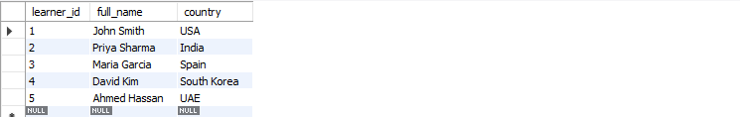

-- Insert Courses
insert into courses (course_name, category, unit_price) values
('Python for Beginners', 'Programming', 49.99),
('Data Science Masterclass', 'Data Science', 89.99),
('Digital Marketing', 'Marketing', 39.99),
('Web Development', 'Programming', 79.99),
('Data Analytics', 'Data Science', 69.99),
('Share Market', 'Data Science', 69.99);
select * from courses;
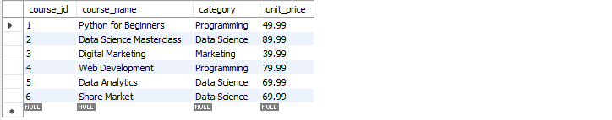

-- Insert Purchases
insert into purchases (learner_id, course_id, quantity, purchase_date) values
-- John Smith (USA)
(1, 1, 1, '2026-01-15'),
(1, 3, 1, '2026-02-10'),
-- Priya Sharma (India)
(2, 1, 1, '2026-01-20'),
(2, 2, 1, '2026-01-25'),
(2, 4, 1, '2026-02-15'),
-- Maria Garcia (Spain)
(3, 2, 1, '2026-02-01'),
(3, 5, 1, '2026-02-20'),
-- David Kim (South Korea)
(4, 4, 1, '2026-01-10'),
-- Ahmed Hassan (UAE)
(5, 3, 2, '2026-02-28');
select * from purchases;
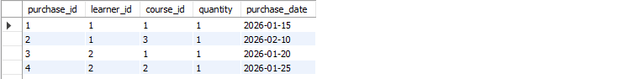

DATA EXPLORATION USING JOINS

INNER JOIN:
select
l.full_name as learner_name,l.country,c.course_name,c.category,p.quantity,
format(c.unit_price, 2) as unit_price,
format(p.quantity * c.unit_price, 2) as total_revenue,
date_format(p.purchase_date, '%Y-%m-%d') AS purchase_date
from purchases p
inner join learners l on p.learner_id = l.learner_id
inner join courses c on p.course_id = c.course_id
order by p.purchase_date desc;
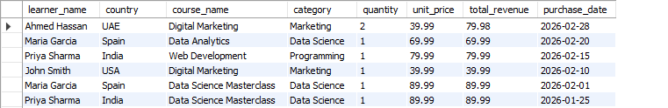

LEFT JOIN:
select
l.full_name as learner_name,l.country,coalesce(c.course_name, 'No Purchase') as course_name,
coalesce(p.quantity, 0) as quantity,
coalesce(format(p.quantity * c.unit_price, 2), '0.00') as total_spent
from learners l
left join purchases p on l.learner_id = p.learner_id
left join courses c on p.course_id = c.course_id
order by total_spent;
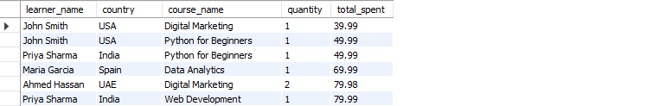

RIGHT JOIN:
select c.course_name,c.category,coalesce(sum(p.quantity), 0) as total_quantity_sold,
coalesce(format(sum(p.quantity * c.unit_price), 2), '0.00') as total_revenue
from purchases p
right join courses c on p.course_id = c.course_id
group by c.course_id, c.course_name, c.category
order by total_quantity_sold desc;


ANALYTICAL QUERIES

Q1: Display each learner's total spending along with their country
select l.full_name as learner_name,l.country,format(coalesce(sum(p.quantity * c.unit_price), 0), 2) as total_spending
from learners l
left join purchases p on l.learner_id = p.learner_id
left join courses c on p.course_id = c.course_id
group by l.learner_id, l.full_name, l.country
order by coalesce(sum(p.quantity * c.unit_price), 0) desc;


Q2: Find the top 3 most purchased courses based on total quantity sold
select c.course_name,c.category,sum(p.quantity) as total_quantity_sold,
format(sum(p.quantity * c.unit_price), 2) as total_revenue
from courses c
inner join purchases p on c.course_id = p.course_id
group by c.course_id, c.course_name, c.category
order by total_quantity_sold desc
limit 3;


Q3: Show each course category's total revenue and number of unique learners
select c.category,
format(sum(p.quantity * c.unit_price), 2) as total_revenue, count(distinct p.learner_id) as unique_learners
from courses c
inner join purchases p on c.course_id = p.course_id
group by c.category
order by sum(p.quantity * c.unit_price) desc;
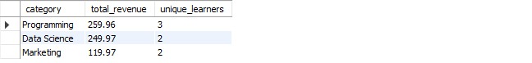

Q4: List all learners who have purchased courses from more than one category
select
l.full_name as learner_name,l.country,count(distinct c.category) as categories_purchased,c.category
from learners l
inner join purchases p on l.learner_id = p.learner_id
inner join courses c on p.course_id = c.course_id
group by l.learner_id, l.full_name, l.country
having count(distinct c.category) > 1
order by categories_purchased desc;

-- Q5: Identify courses that have not been purchased at all
select c.course_id,c.course_name,c.category,format(c.unit_price, 2) AS unit_price
from courses c
left join purchases p ON c.course_id = p.course_id
where p.purchase_id is null
order by c.course_name;

Insights from the E-Learning Database

1. Top Revenue Generating Category
The Data Science category generates the highest revenue because multiple learners purchased:
- Data Science Masterclass
- Data Analytics
- Share Market
Insight:
Data Science courses are highly demanded and profitable.

2. Most Popular Courses
Courses with highest purchases:
- Python for Beginners
- Digital Marketing
- Data Science Masterclass
Insight:
Beginner-friendly and career-oriented courses attract more learners.

3. Multi-Category Learners
Some learners purchased courses from more than one category.
Example:
- Priya Sharma purchased:
  - Programming
  - Data Science
Insight:
Cross-category learners are more engaged and valuable customers.

4. Country-Based Customer Trends
Different countries are purchasing courses.
Examples:
- India → multiple purchases
- UAE → higher quantity purchase
Insight:
International learners show strong market potential.

5. Unsold Courses
1 course “Share Market” is courses not purchased at all.
Insight:
These courses may need:
- better marketing
- discounts
- updated content

Data Analysis

1. Descriptive Analysis (What Happened?)
Shows category-wise revenue.
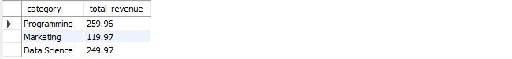

2. Diagnostic Analysis (Why Happened?)
Programming Category performs better because:
- high-demand skills
- multiple course offerings

3. Predictive Analysis (What may happen in future?)
If more AI/Data Science and programming courses are added,
overall revenue may increase.

4. Prescriptive Analysis (What should the business do?”)
Create combo offers:
Python + Data Science Masterclass

